

**AI2002 – Artificial Intelligence**

**Practice Questions**

**First Order Logic**

|  |  |
| --- | --- |
| **Instructor:** | Mahzaib Younas |
| **Email:** | [mahzaib.younas@nu.edu.pk](mailto:mahzaib.younas@nu.edu.pk) |
| **Semester:** | Spring 2024 |
| **Section:** | BSCS-6A |

**Question 1:**

**In a kingdom, there are various social hierarchies beyond just being a knight, peasant, or noble. Nobles are not only knights but also have the additional responsibility of being landowners. Peasants, on the other hand, may or may not be serfs, depending on whether they work directly for a noble. Express these intricate relationships using first-order logic.**

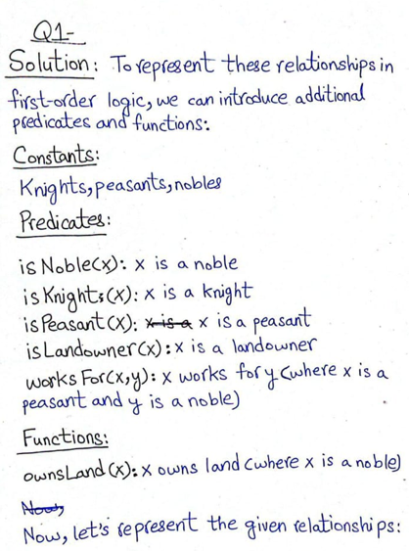

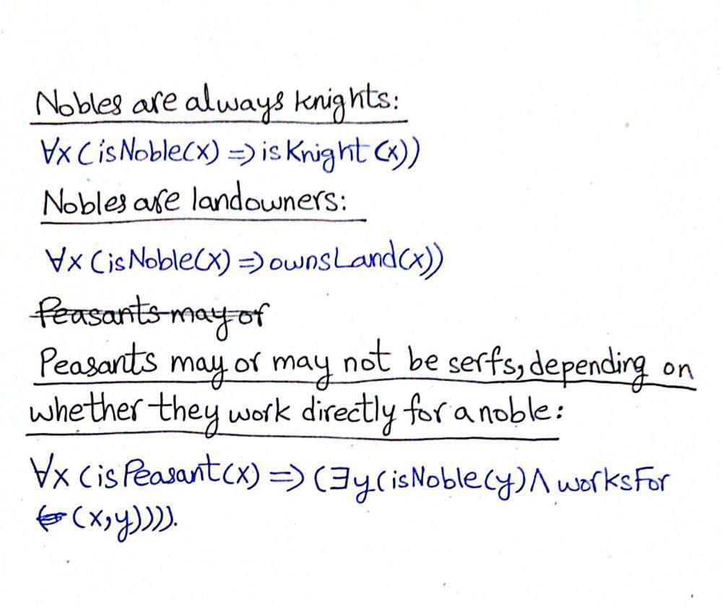

**Question 2:**

**In a diverse society, marriages are not strictly limited to the binary notion of husband and wife. There are instances of same-sex marriages and polyamorous relationships. Additionally, marriages can be temporary or permanent. How would you represent the intricate dynamics of marriage using first-order logic, considering these complexities?**

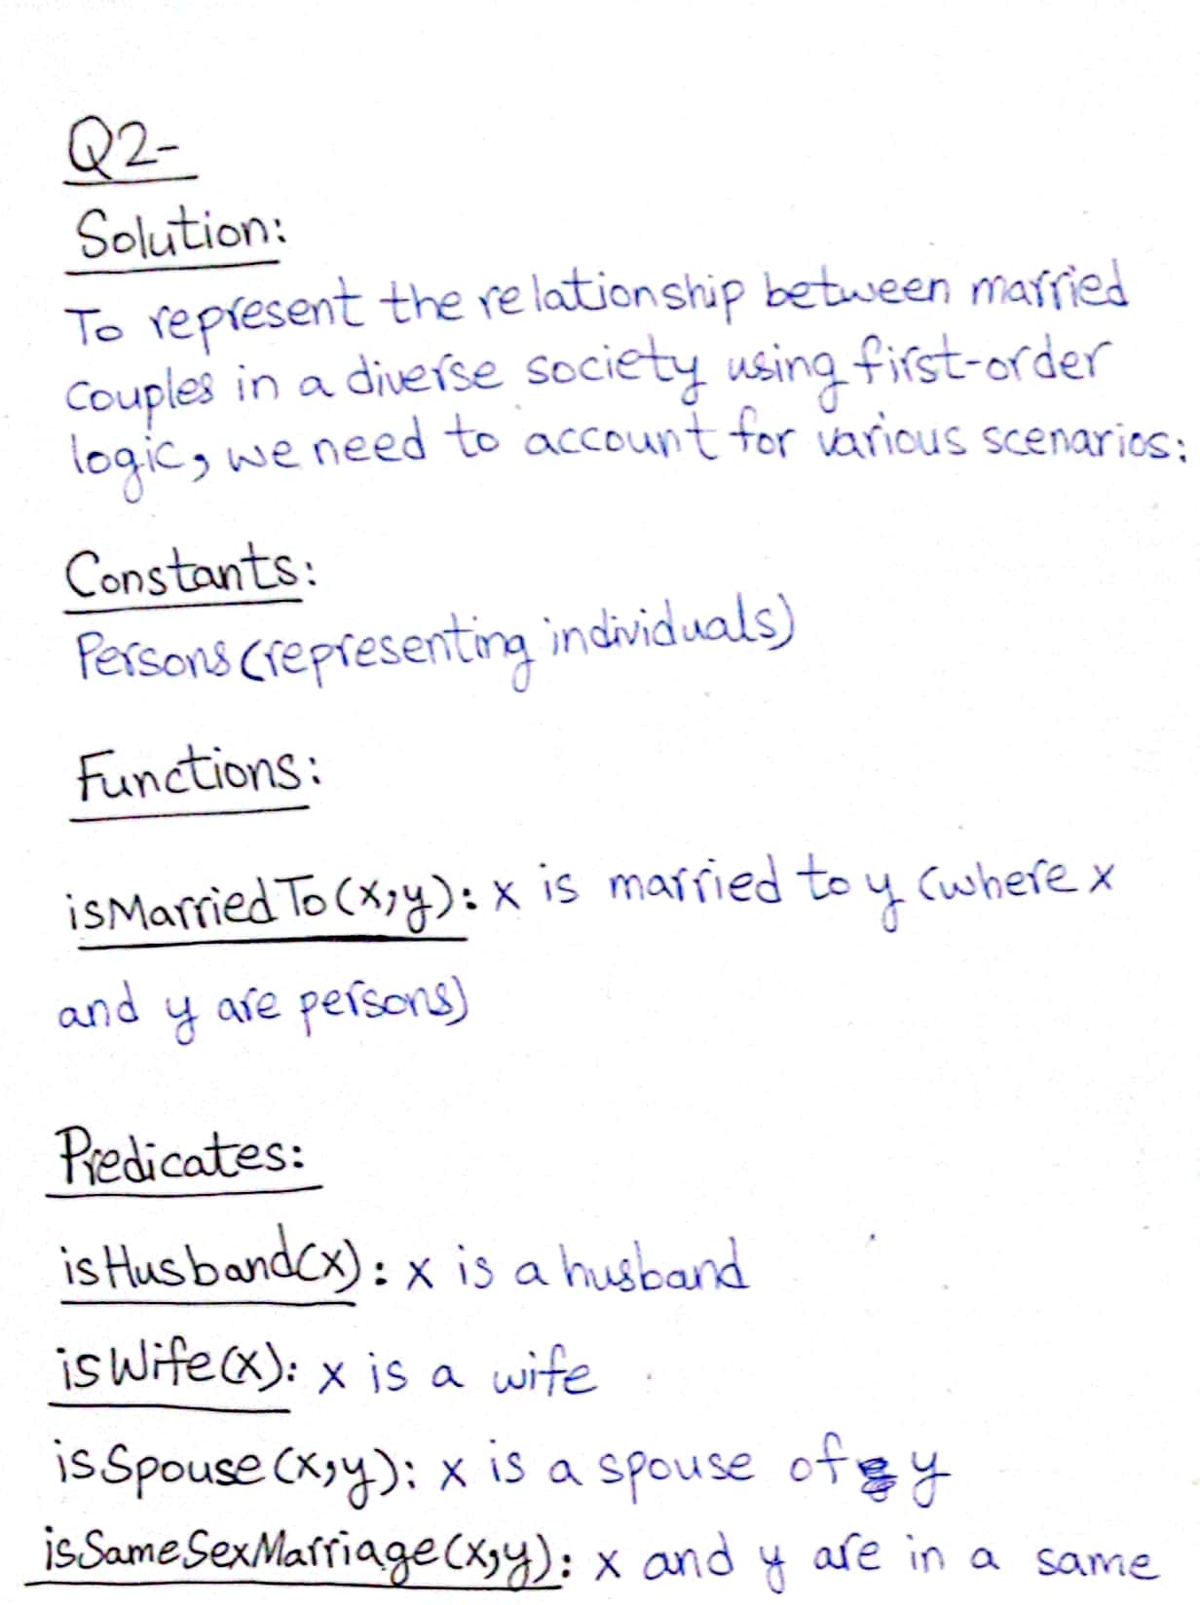

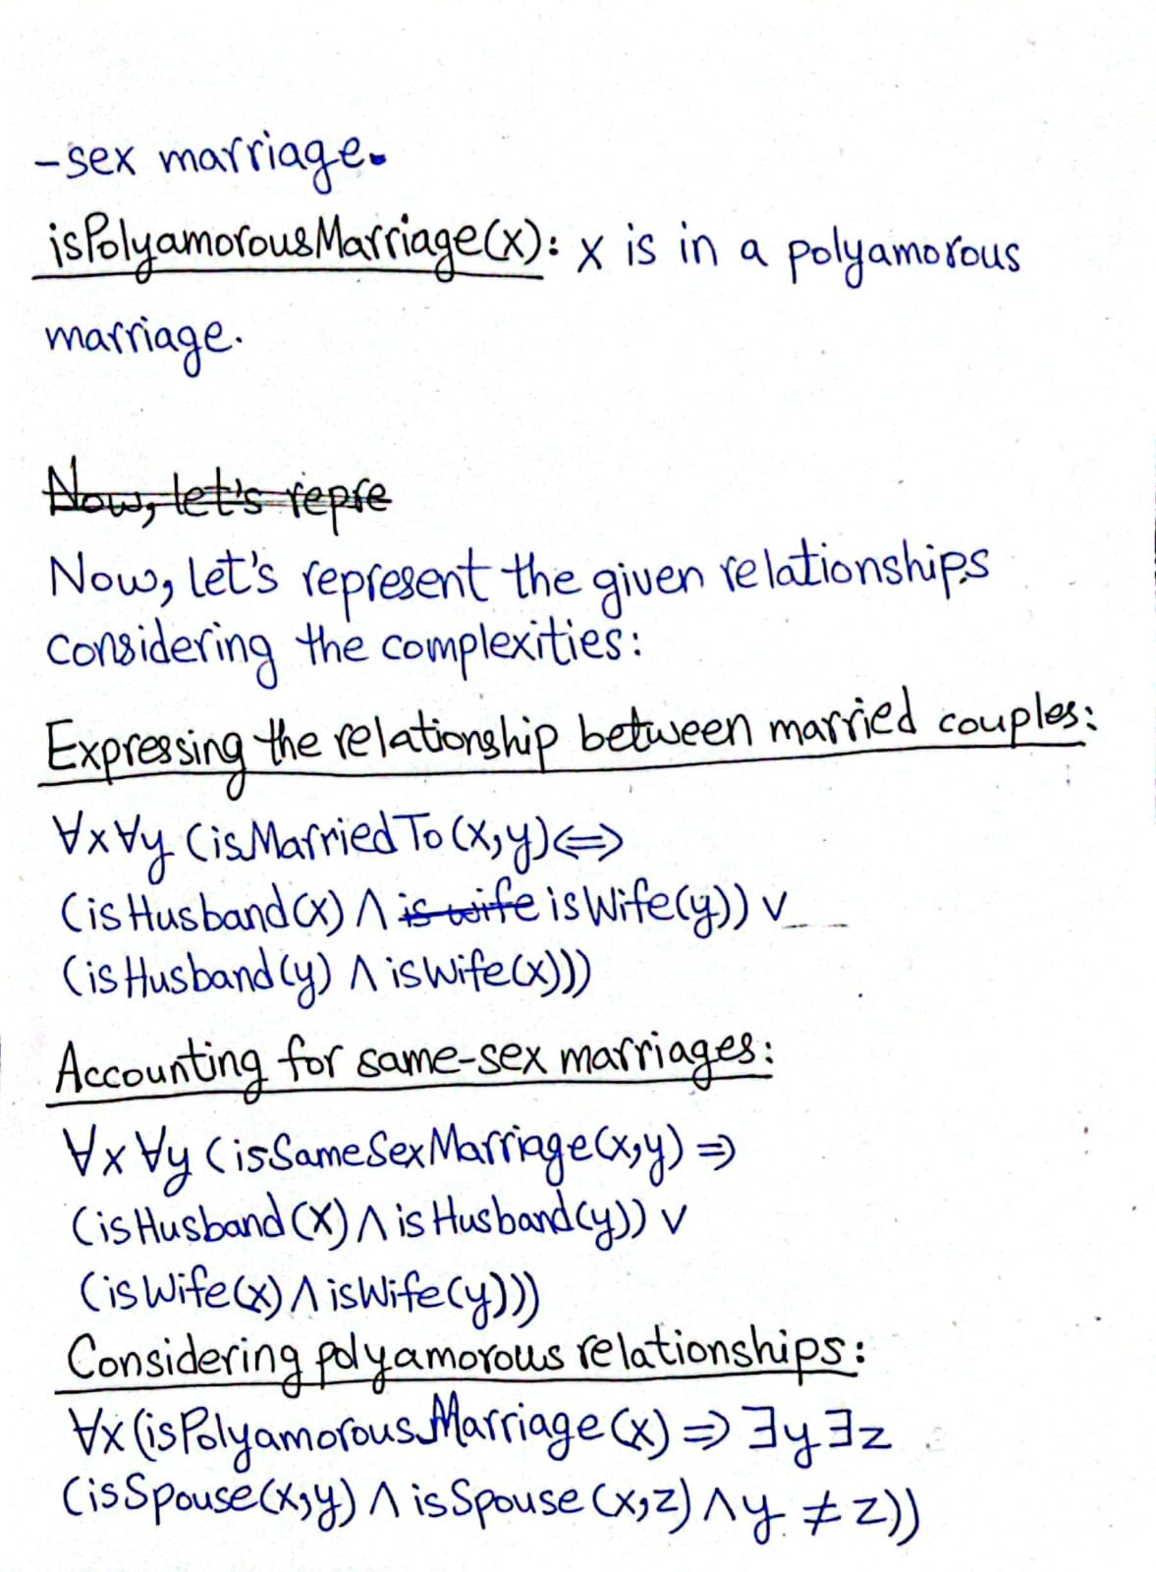

**Question 3:**

**In a futuristic library system, books can belong to multiple genres simultaneously, and new genres can be dynamically created based on user preferences. Additionally, some books might transition from one genre to another over time. How would you represent the dynamic relationship of books belonging to genres using first-order logic, considering these complexities?**

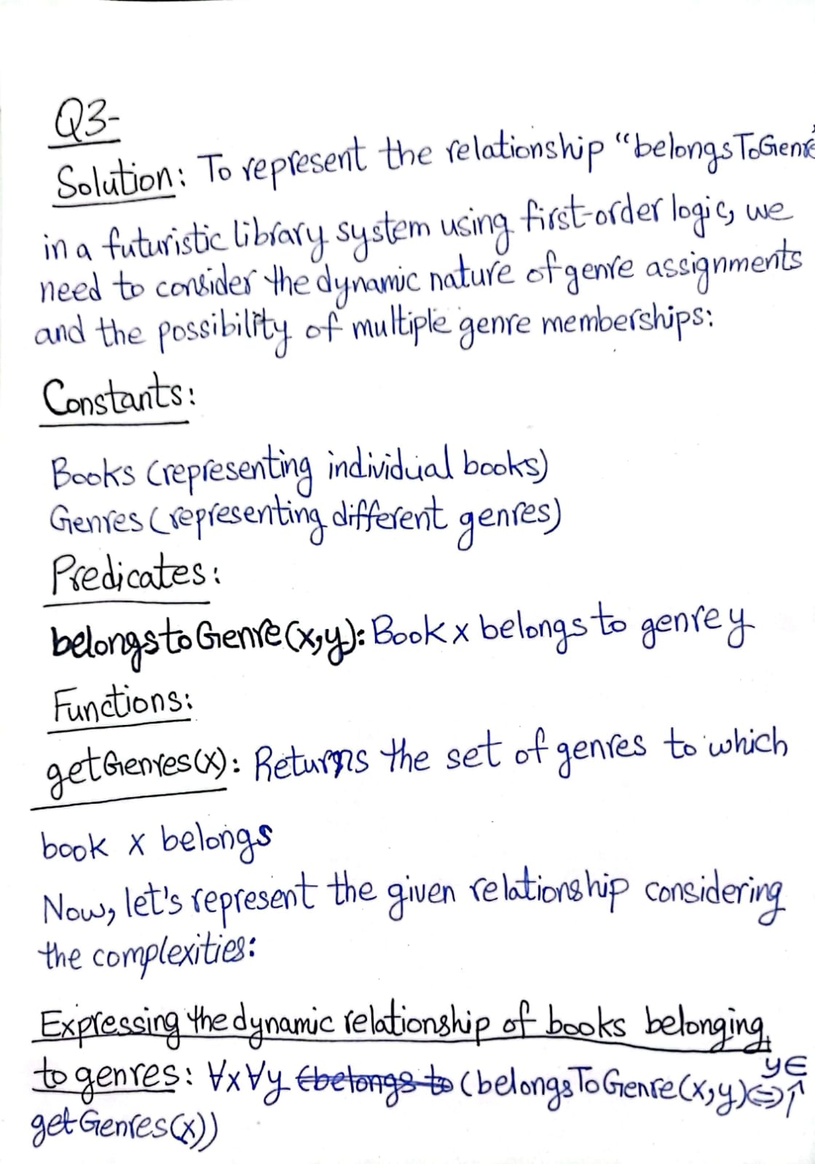

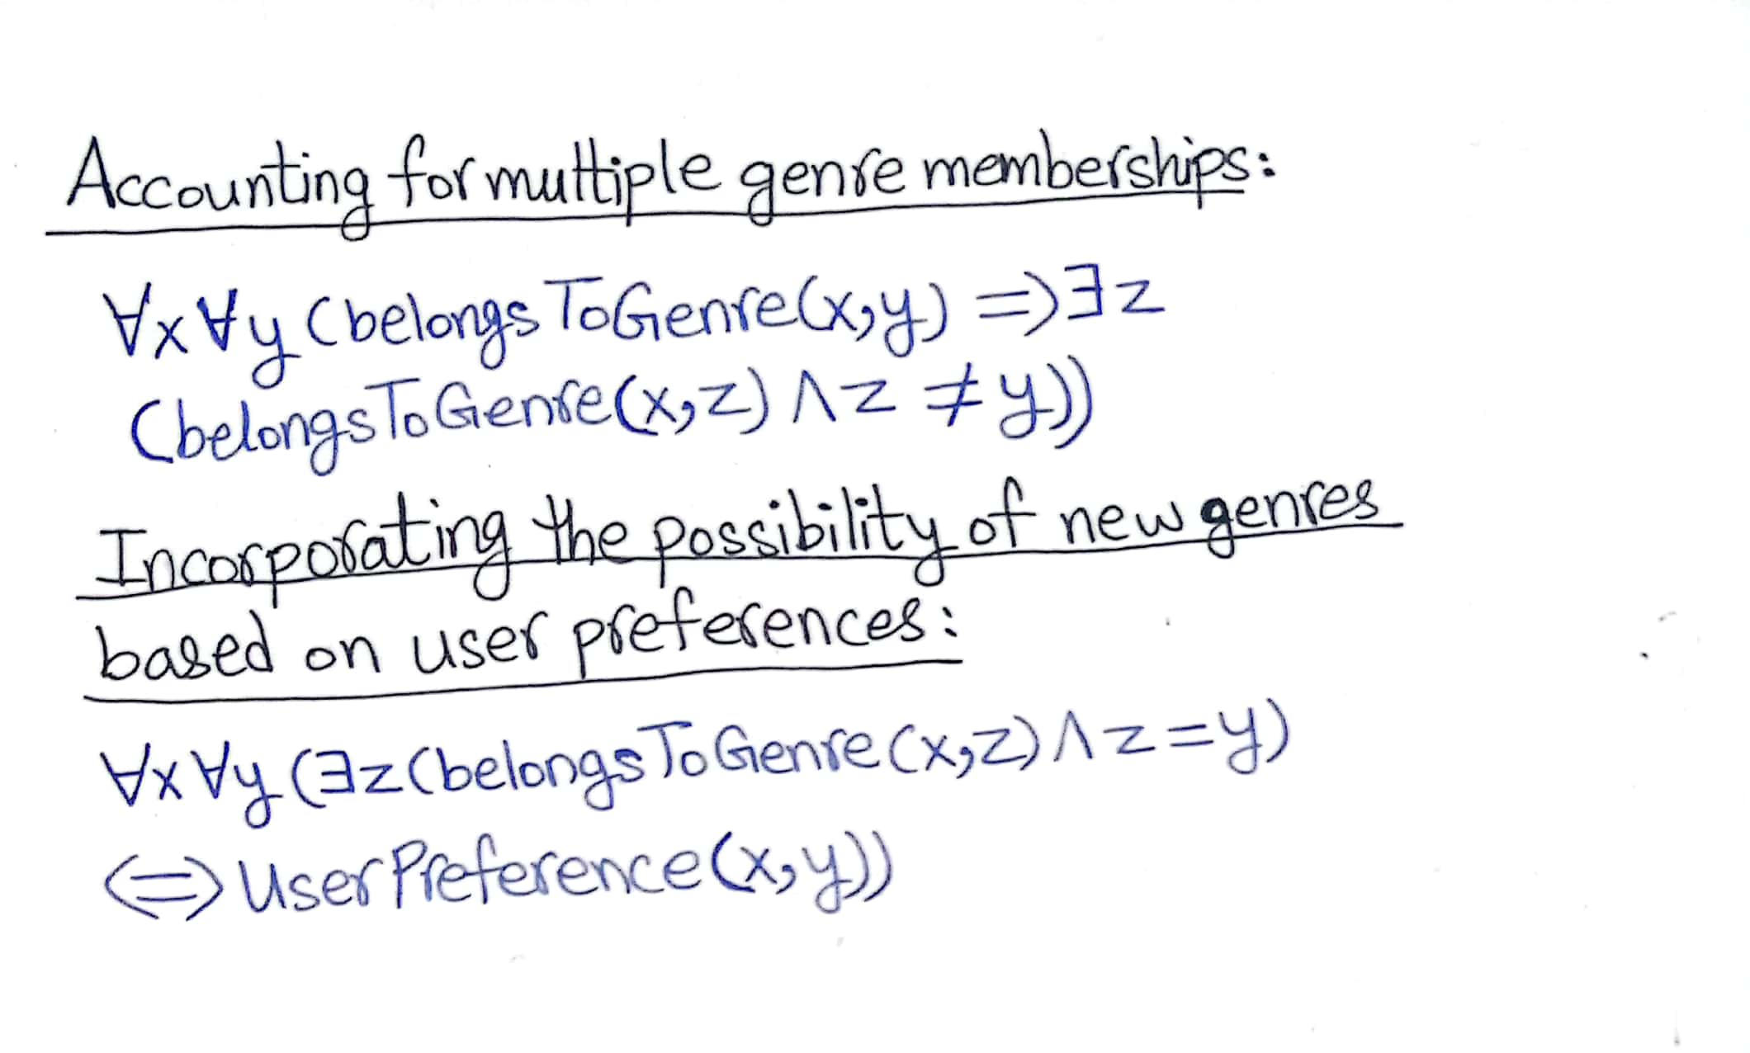

**Question 4:**

**In the vast ecosystem of a futuristic zoo, animals exhibit complex predator-prey relationships, where some animals may be predators of multiple species while others might be prey to certain predators. Additionally, the relationships between predators and prey evolve dynamically over time due to ecological changes. How would you represent the intricate predator-prey relationships using first-order logic, considering these complexities?**

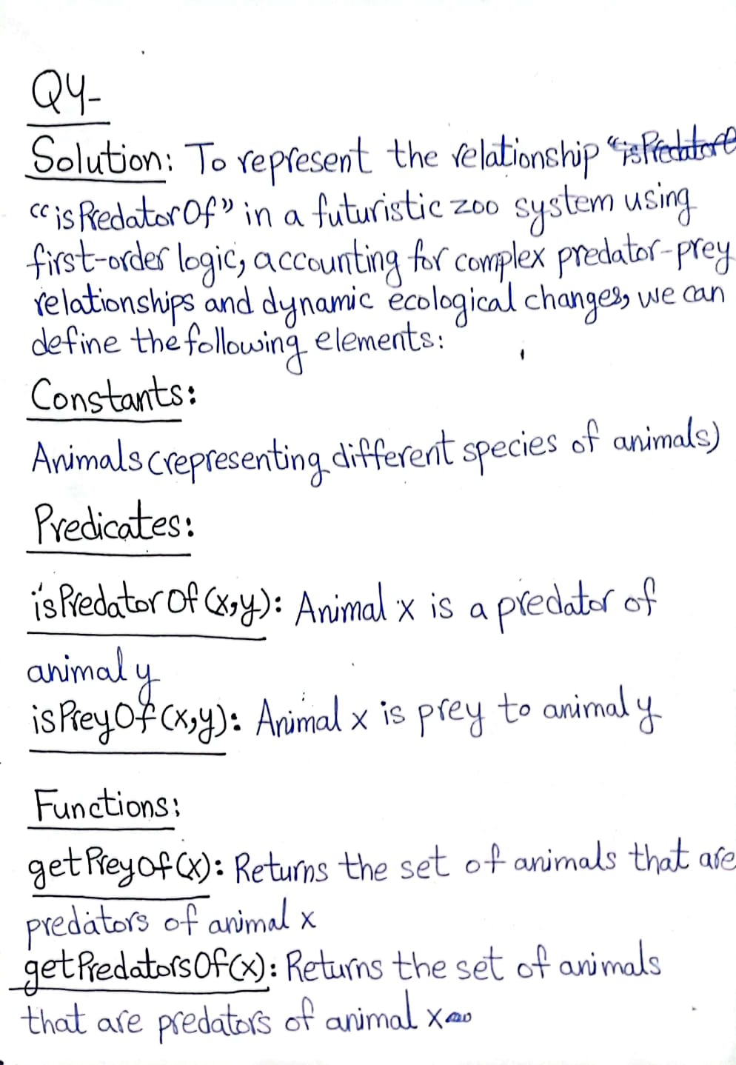

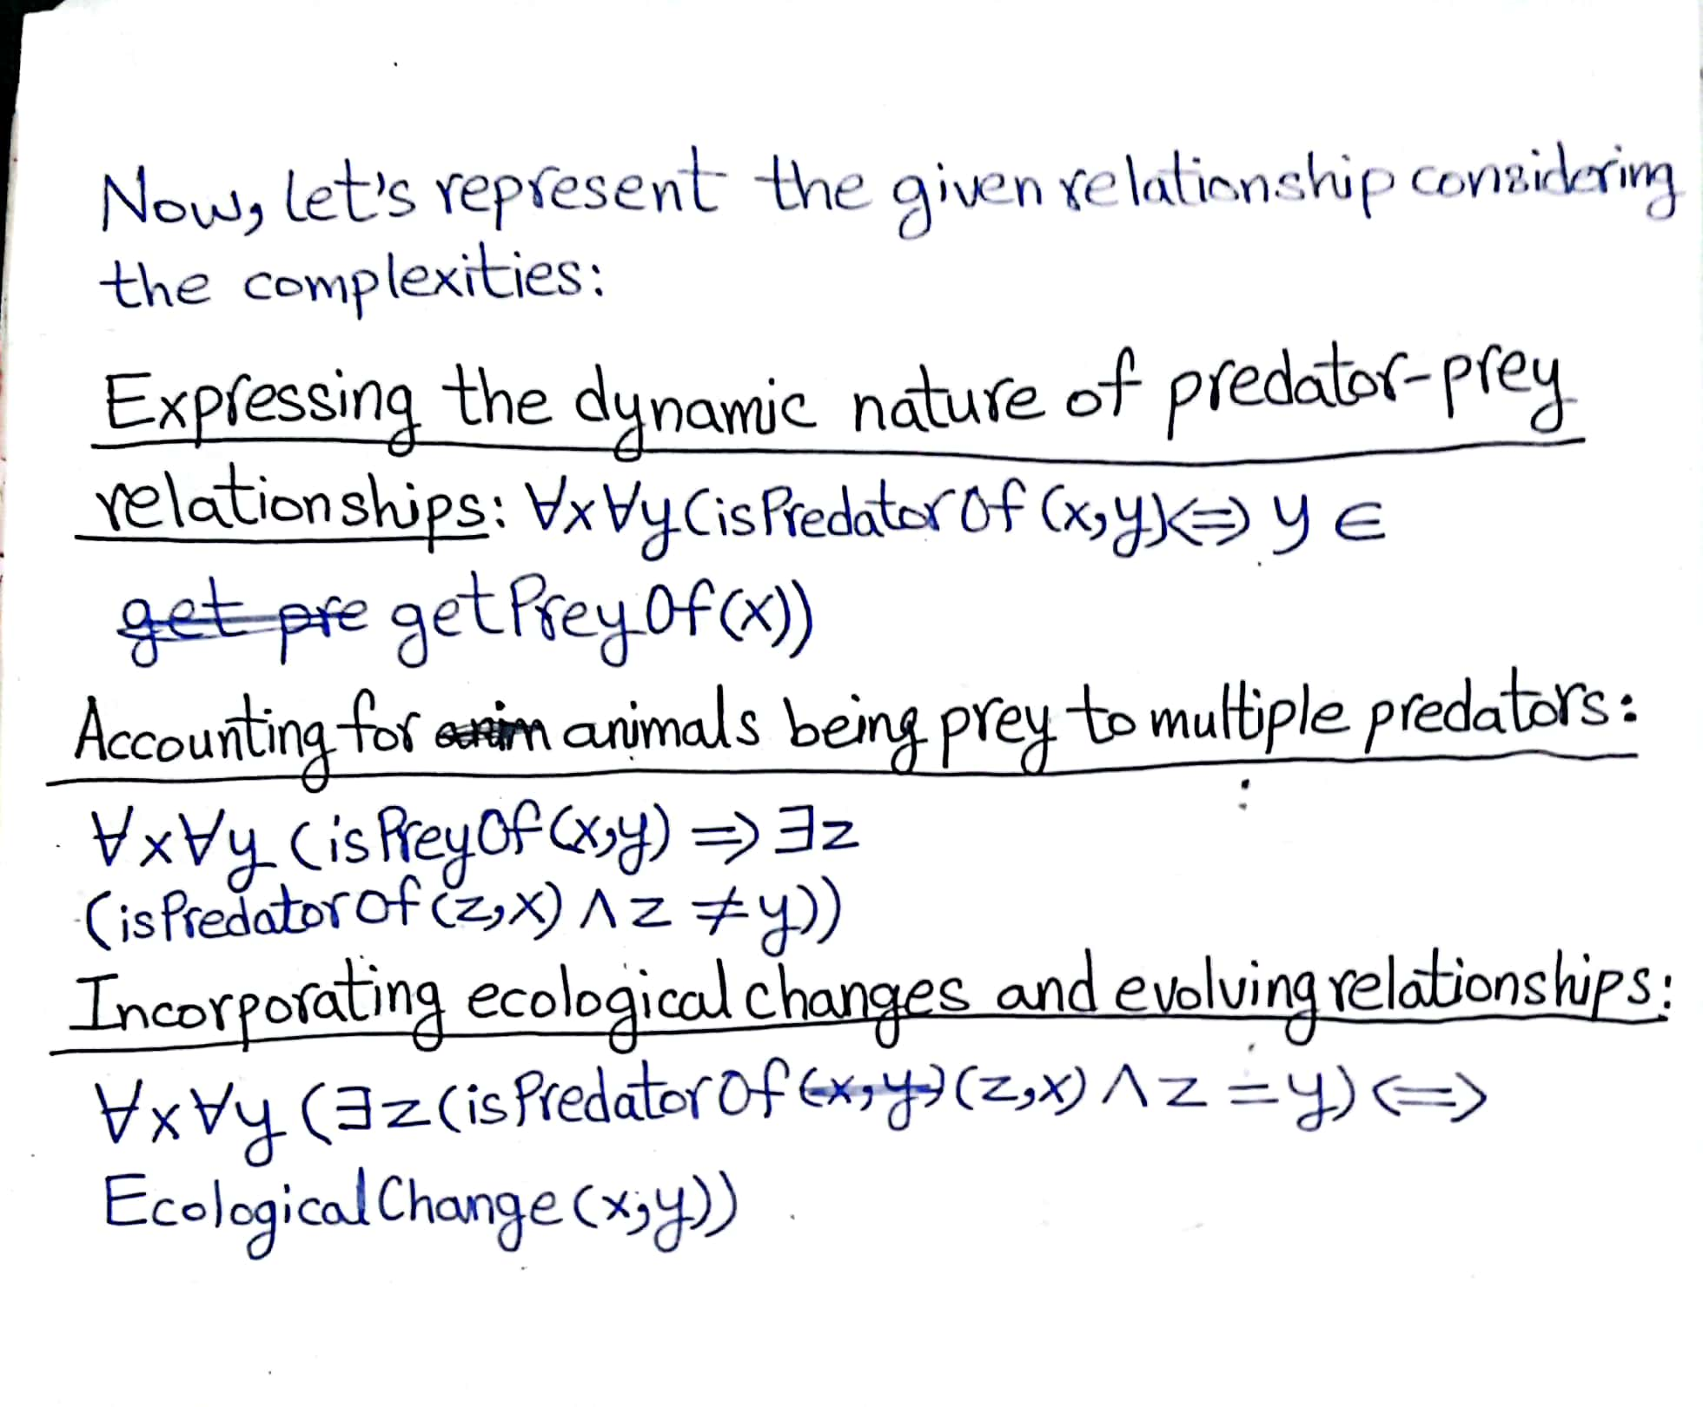

**Question 5:**

**Consider a sprawling royal family with intricate lineage and complex familial ties, where siblingship extends beyond direct biological relations to include half-siblings, stepsiblings, and adopted siblings. Additionally, certain cultural and legal nuances influence the recognition of sibling relationships. How would you represent the multifaceted relationship between siblings using first-order logic, considering these complexities?**

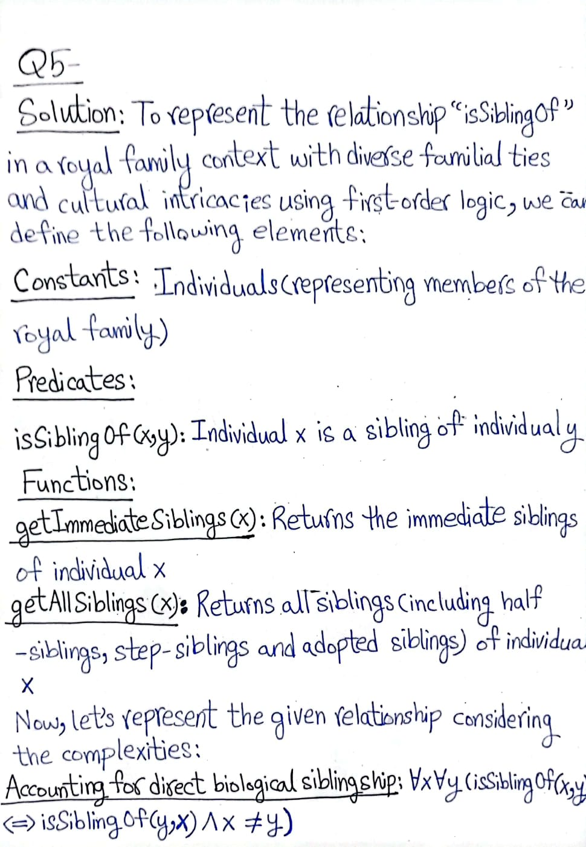

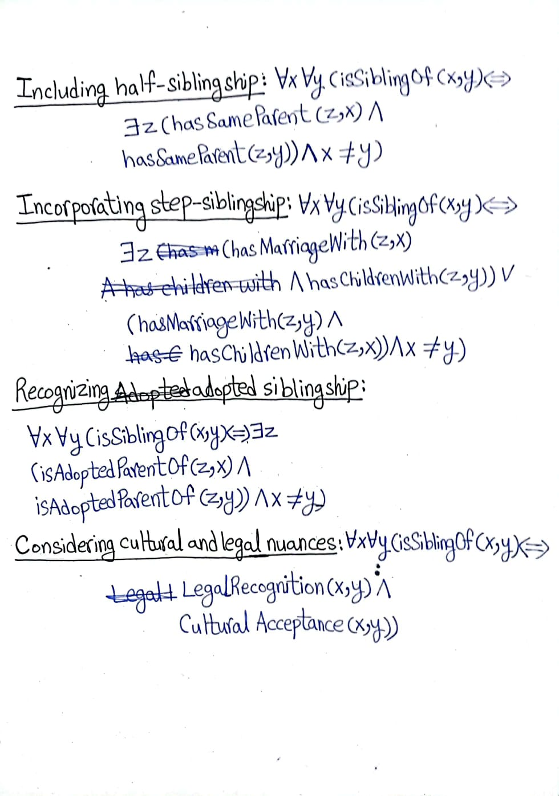

**Question 6:**

**Consider a dynamic royal court where relationships and attributes evolve over time. Initially, the court comprises King John and Richard the Lionheart, with John wearing a crown and Richard identified as his brother. Further, the left legs of both individuals are distinct. Additionally, it's established that John is the sole king among the mentioned individuals. Now, envision scenarios where the royal family expands, crown ownership shifts, sibling relationships evolve symmetrically, and physical attributes undergo transformations.**

1. **Extended Royal Siblinghood: In an expanded model, where Richard and John have another sibling named Mary, extend the Brother relation to incorporate Mary's siblinghood with both Richard and John using first-order logic.**
2. **Regal Heirloom: Introduce a scenario where not only does the queen wear a crown, but also passes it down to her successor. Adjust the existing relations or introduce new ones to represent the inheritance of the crown within the royal lineage using first-order logic.**
3. **Symmetric Siblinghood Expansion: Expand the model to include a symmetric sibling relationship among all members of the royal family, including extended relatives and adoptees, using first-order logic.**
4. **Crown Transfer Dynamics: Suppose the crown ownership changes hands frequently among the royal family members due to political intrigues. Update the model dynamically to reflect these changes in crown ownership using first-order logic.**
5. **Leg Unification Scenario: Imagine a scenario where Richard and John undergo a miraculous transformation, resulting in their left legs becoming identical. Modify the model to represent this transformation accurately using first-order logic, considering the implications of such a change on the existing facts.**

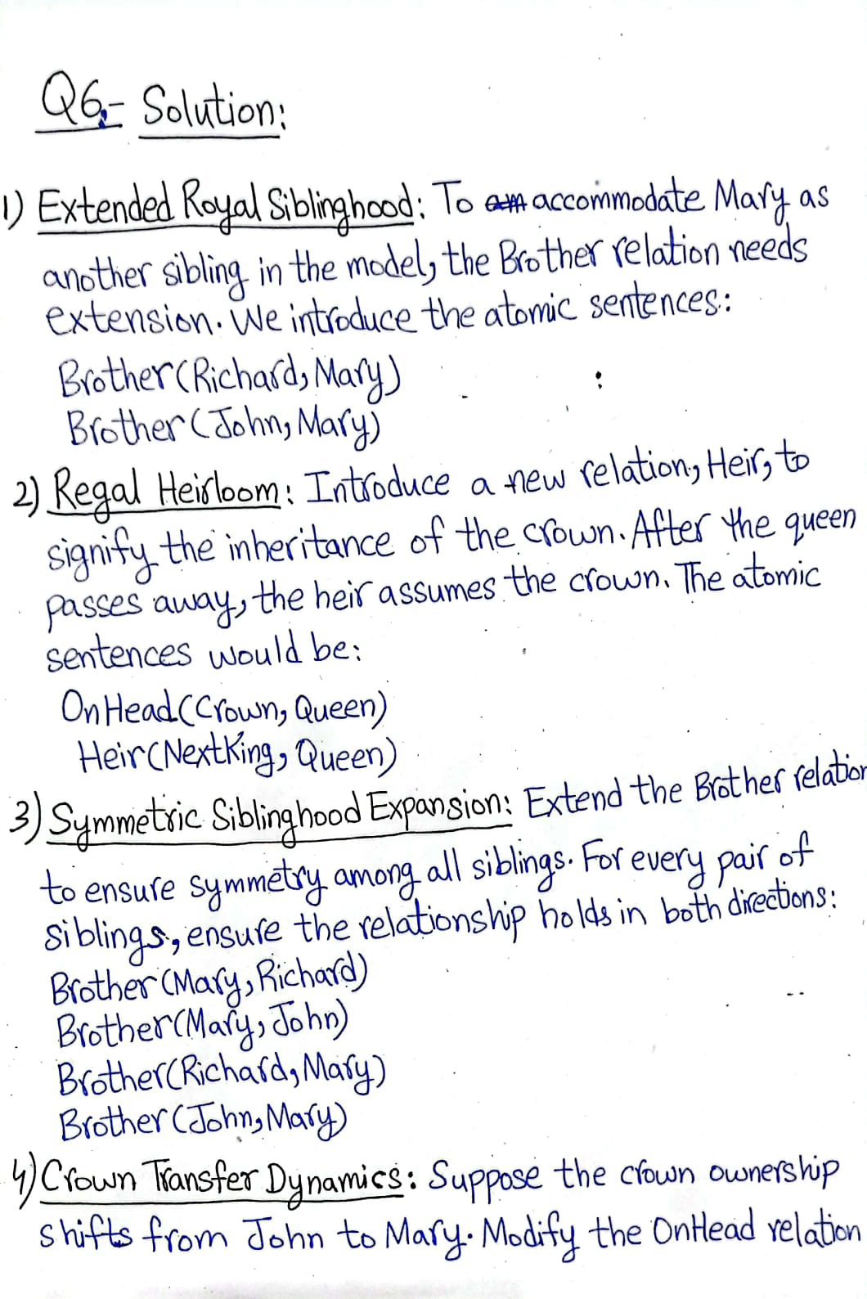

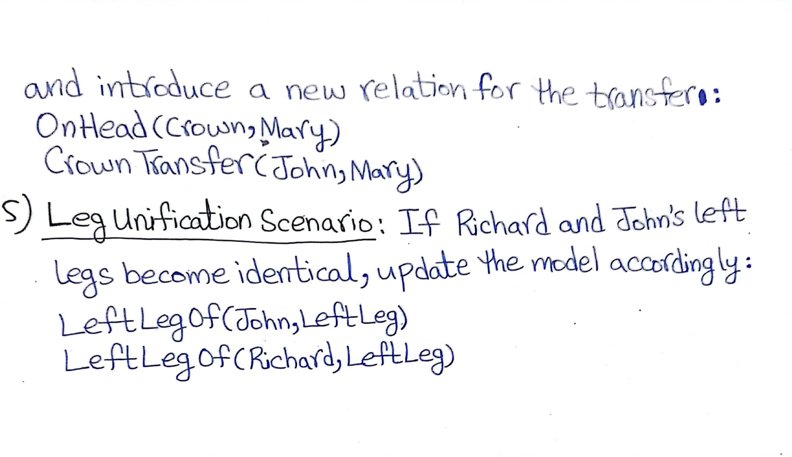

**Question 7:**

**Show progressive unification step-by-step for the sentences "O(F(y), y)" and "O(F(x), J)" to find a unifier.**

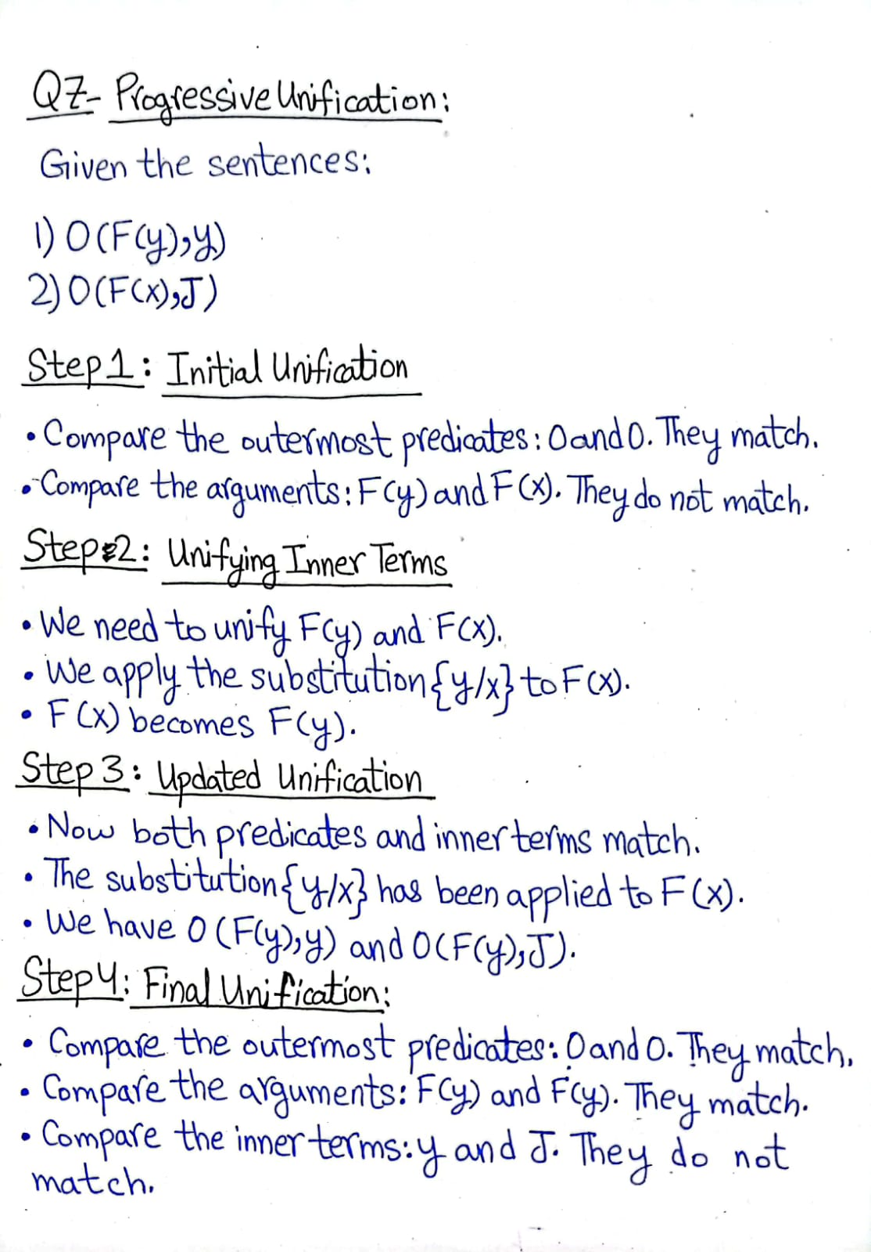

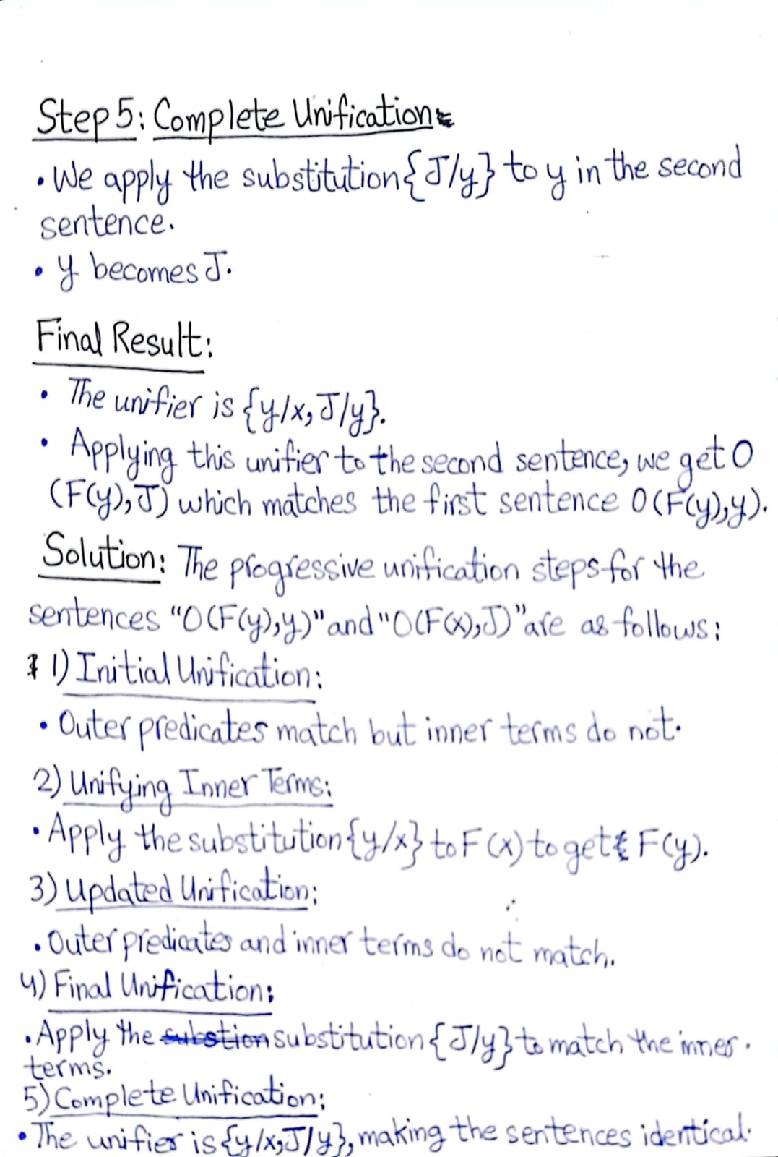

**Question 8:**

**Given the knowledge that all kings are greedy, and John is a king, infer whether John is greedy using first-order logic inference.**

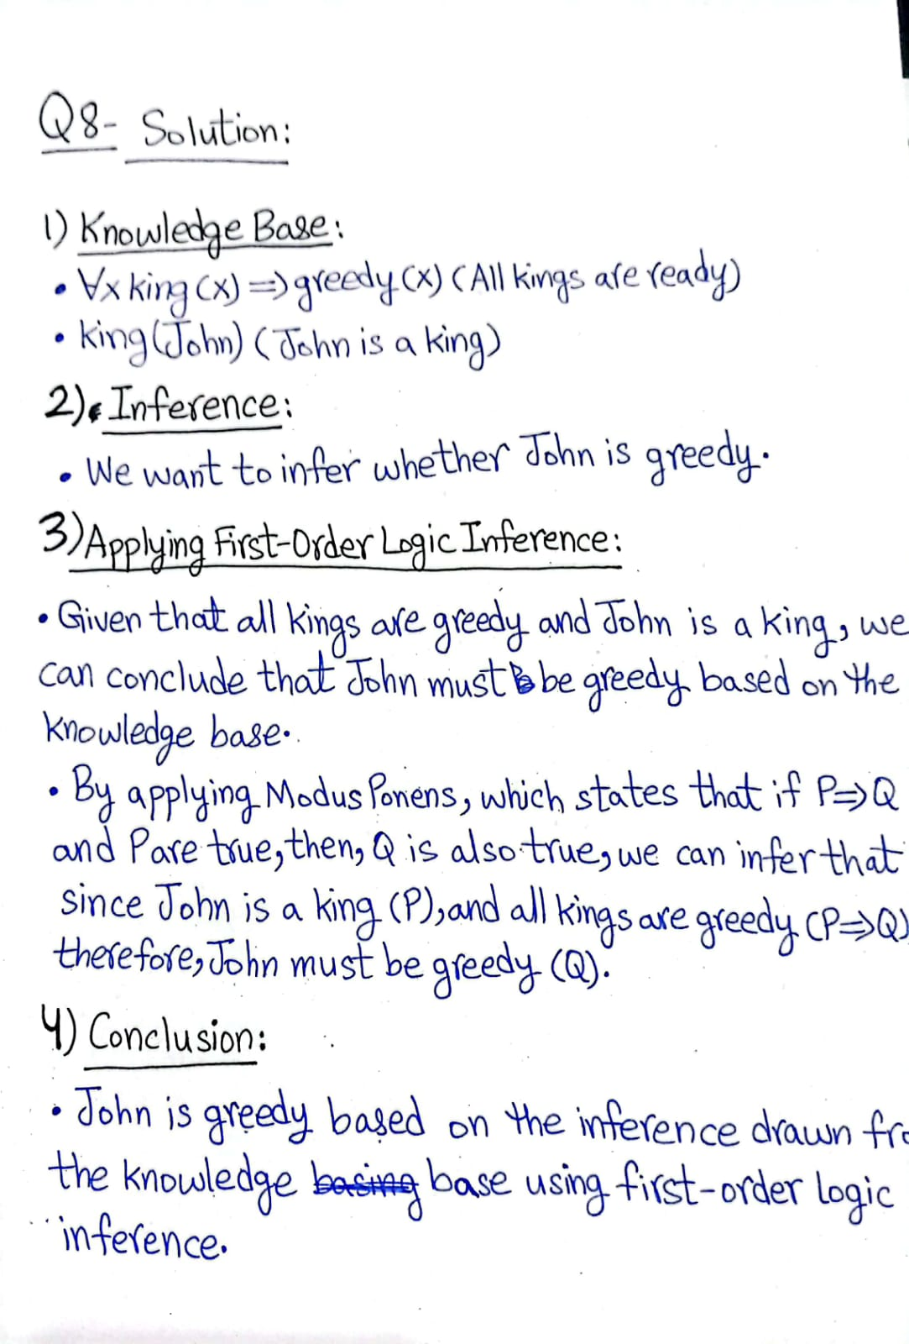

**Thank You**